Introduction

Prostate enlargement, also called Prostatomegaly is comprised of two components. The first component is the ballooning of the prostatic glands either from inflammation (Prostatitis) or fluid retention due to lack of ejaculation. The second component is muscle enlargement (Benign Prostatic Hypertrophy). Ballooning of the glands due to inflammation is often seen in men below 40 years of age, whereas in older men, muscle enlargement is more common. The presence of both components in the older group is also commonplace (See Figure 1).

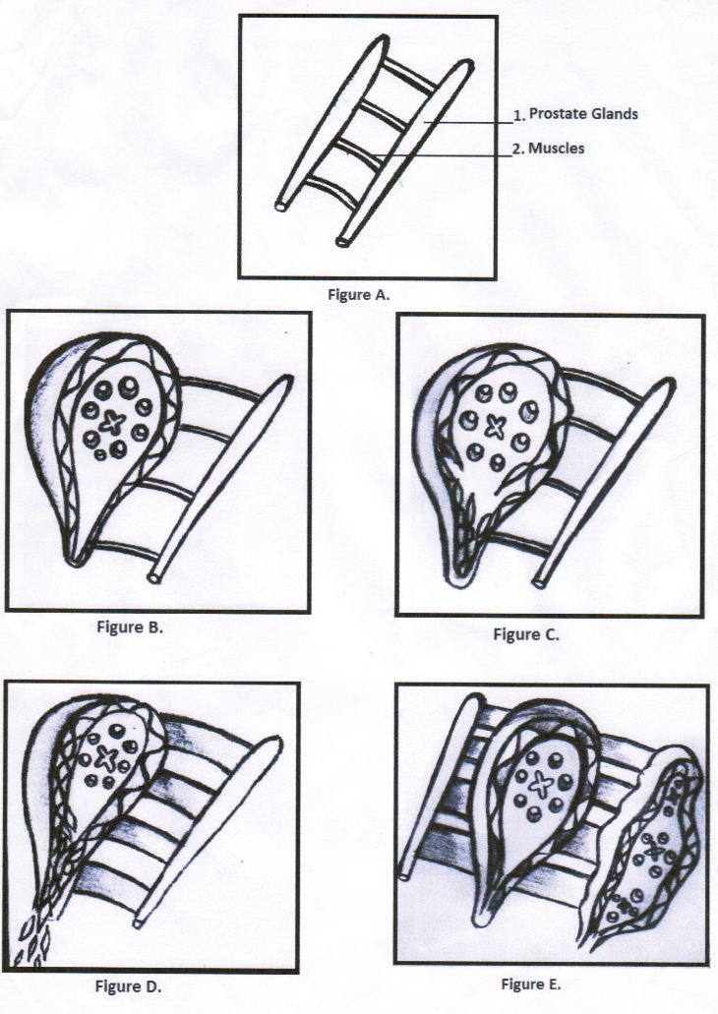

Symptoms

Generally, the symptoms of prostatic diseases (Table 1) can be grouped into four categories: (1) pain, (2) urinary dysfunction, (3) sexual symptoms, and (4) others (Table 2). Prostate enlargement involving the second component manifests predominantly as urinary symptoms; however, other symptoms such as pain may also be present. Symptoms come gradually and become progressively more severe; thus, they often go unrecognized until urinary obstruction occurs.

Table 1 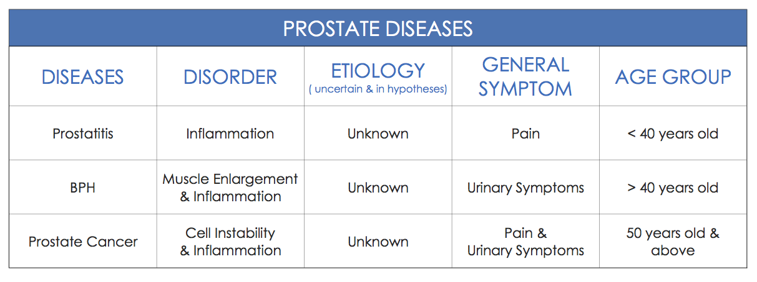

Table 2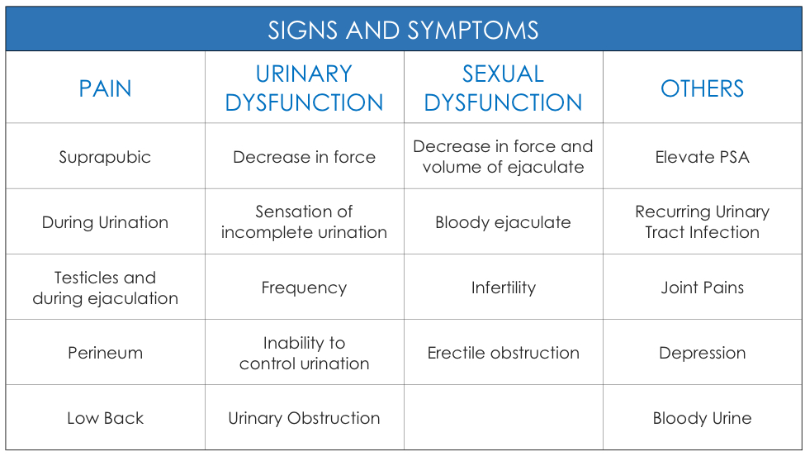

Diagnosis

A diagnosis of prostatic enlargement is considered when (1) the volume of the prostate exceeds 20 – 25 cc depending on the patient’s height, and (2) a post void urine residual of more than 50 cc. This may be determined through digital rectal exam (DRE) and radiological studies.

Treatment

Prostate enlargement may be managed by medical therapy or surgical treatment.

As mentioned previously, prostatic enlargement is made up of two components. In medical management, the first component (Prostatitis) is the first to be eliminated. Afterwards, a radiological study is done comparing the baseline study with one obtained after prostatitis treatment.

The patient should be reassessed for the following: decrease in symptom score, decrease in post void urine residual, and decrease in prostate size. If there is a decrease in symptom score and post void urine residual is below 50 cc, no further treatment is necessary other than the patient returning after a year for follow-up. If post void urine residual is above 50 cc, medications that relax the prostate may be used. If the size of the prostate is more than 30 grams, medications that suppress the male hormone may be added. The patient is also recommended to return for follow-up after four months.

If after two years the patient continues to have a low symptom score and post void urine residual below 50 cc, surgical treatment is unnecessary and medication may be withdrawn. If the symptom score does not improve, the post void urine residual continues to increase, and there is continuous increase in prostate size, surgical intervention may be considered.

